Abstract

Coronavirus disease is an infectious and contagious disease caused by a newly discovered coronavirus. People usually feel moderate fever, cough, fatigue respiratory problems and joints pain. However this is not sufficient to diagnose this illness. Different individuals have also shown a different set of symptoms too.[1]

Several outbreak prediction models for COVID-19 are being used by concerned authorities and informed and planned decisions are being made on the basis of that prediction. However due to a high level of uncertainty and lack of essential data, standard models have shown low accuracy. Our algorithm produces promising results via SVM and CNN. Since COVID-19 has a highly complex nature of symptoms it becomes considerably difficult to rely completely on individual test results. Rather this algorithm combines datasets from different tests, namely antigen and RT-PCR tests.

Virologists and doctors are working day and night to make test results more and more reliable by observations and hit and trial. All these results are limited to the computational capacity of human brain, which is brilliant in itself but also susceptible to errors. This is high time we use neural networks and use its impeccable computational abilities.

The novel coronavirus has hampered the economy growth all across the planet and we need a fast recovery. For that we need to mingle technology with traditional methods. The algorithm will be useful in labs where huge amounts of data will used to increase its accuracy.

**Introduction**

The first human cases of COVID-19, the disease caused by the novel coronavirus causing COVID-19, subsequently named SARS-CoV-2 were first reported by officials in Wuhan City, China, in December 2019.[2]

Gradually it spreads throughout the world via means of people travelling abroad for trade or personal reasons. A 34 years old Chinese ophthalmologist Li Wenliang[3] raised an alarm of a new disease that could possibly a threat to humans. Initially it was confused with the airborne disease SARS (Severe acute respiratory syndrome) which affected 26 countries and resulted in more than 8000 cases in 2003. However the Chinese health department believed it to return after 16 long years.[4]

Coronavirus species already existed in nature. It was first recorded in 1920. However, the first case of human coronavirus infection was recorded in the 1960s. In 2019 a man Wuhan Province, china is believed to be the first case of covid-19. This virus was completely new to the recorded specimens. [5]

Viruses are known to mutate within months if given the proper environment. Novel Coronavirus disease is one such disease which infected tens of millions and affected lives of billions of people.

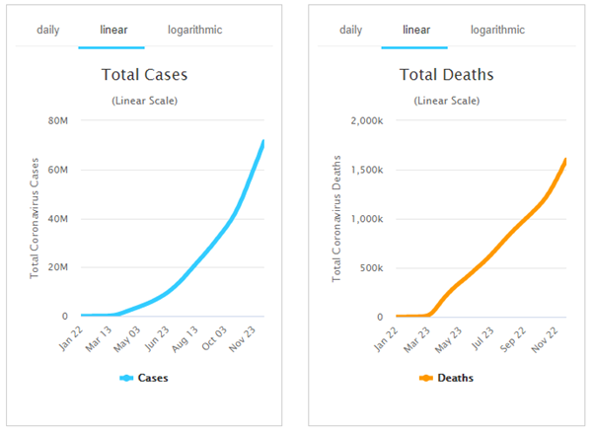

Humanity has survived other deadly viruses like Ebola where the mortality rate was as high as 88%. However it was highly improbable that the infected person will affect a big amount of population since the symptoms would show up in less than 5 days and the person would then be unable to move around because of fatigue.[6]

The coronavirus COVID-19 is affecting 218 countries and territories around the world and 2 international conveyances.[7]

However the person affected with Coronavirus would take somewhere between 15-21 days to show up symptoms like mild fever and headache. This time frame and ignorance of mistaking Coronavirus as common cold people wouldn’t quarantine themselves and this helped spreading of disease much faster all across the world.

To prevent load on healthcare systems many countries went to a series of countrywide lockdown. Meanwhile millions of people were tested in different regions to quarantine the infected individuals.

This lead to collapsing of global economy. Millions[8] of people lost their jobs and GDP growth of developed and developing nations went in negative[9] phase. This led to even bigger problems. The people who lost their jobs will reduce their monthly expenditure, which will reduce the demand of goods, which in turn reduce the supply of goods and small and medium scale factories will fire more employees to meet their own expenses. This led to even more employment.[10]

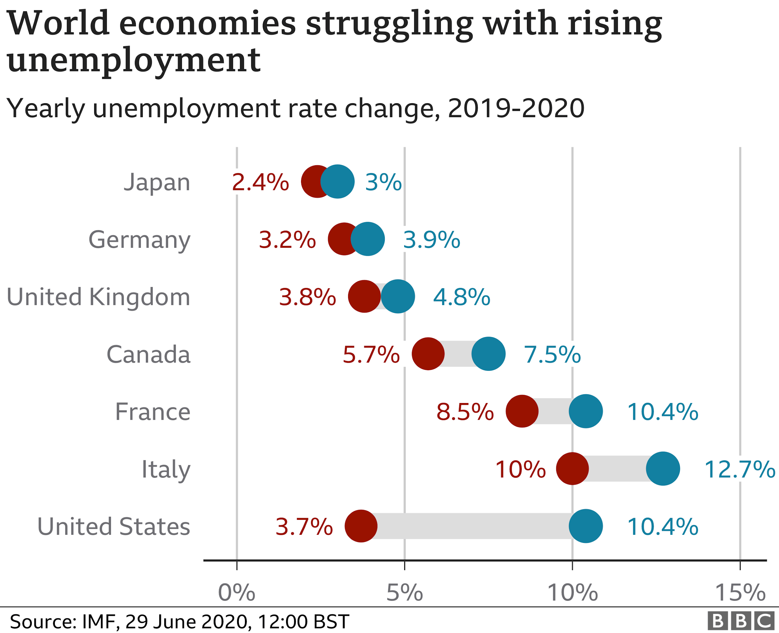

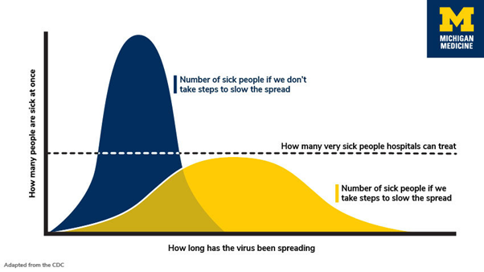[11]

However despite our exhaustive defensive strategies the nations worldwide failed to contain the virus. All they could do is strengthen their healthcare facilities like making more beds and ventilators available so that they can prepare beforehand.

The growth curve of Covid19-is exponential. Also unlike initial spread where RT-PCR tests were common, today most of the hospitals are focusing on Antigen tests. Which has a benefit that it can give test results very rapidly but it comes with a major drawback. It can also give false negatives. Sometimes doctors suggest PCR tests to confirm the same.

1. "Coronavirus disease (COVID-19) advice for the public - World ...." <https://www.who.int/emergencies/diseases/novel-coronavirus-2019/advice-for-public>. Accessed 12 Dec. 2020.
2. "Coronavirus & COVID-19 Overview: Symptoms, Risks ...." 29 Sep. 2020, <https://www.webmd.com/lung/coronavirus>. Accessed 12 Dec. 2020.
3. "Li Wenliang: Coronavirus kills Chinese whistleblower doctor ...." 7 Feb. 2020, <https://www.bbc.com/news/world-asia-china-51403795>. Accessed 12 Dec. 2020.
4. "Severe Acute Respiratory Syndrome (SARS ...." <https://www.who.int/health-topics/severe-acute-respiratory-syndrome>. Accessed 12 Dec. 2020.
5. "COVID-19 pandemic - Wikipedia." <https://en.wikipedia.org/wiki/COVID-19_pandemic>. Accessed 12 Dec. 2020.
6. "Ebola virus disease - World Health Organization." 10 Feb. 2020, <https://www.who.int/news-room/fact-sheets/detail/ebola-virus-disease>. Accessed 12 Dec. 2020.
7. "Coronavirus Update (Live) - Worldometer." <https://www.worldometers.info/coronavirus/>. Accessed 12 Dec. 2020.
8. "Around 12.2 crore people lost their jobs: How Covid-19 will ...." 21 Aug. 2020, <https://www.indiatoday.in/education-today/jobs-and-careers/story/around-12-2-crore-people-lost-their-jobs-how-covid-19-will-change-job-prospects-and-hiring-in-india-1713616-2020-08-21>. Accessed 12 Dec. 2020.
9. "Which top economies have suffered worst GDP fall due to ...." 1 Sep. 2020, <https://www.businesstoday.in/current/economy-politics/which-top-economies-have-suffered-worst-gdp-fall-due-to-covid-19/story/414683.html>. Accessed 12 Dec. 2020.
10. "Coronavirus: A visual guide to the economic impact - BBC News." 29 Jun. 2020, <https://www.bbc.com/news/business-51706225>. Accessed 12 Dec. 2020.
11. "Is social distancing working? Here's what you need to know ...." 1 Apr. 2020, <https://www.michiganradio.org/post/social-distancing-working-heres-what-you-need-know>. Accessed 12 Dec. 2020.